Emai unsubscribe Process:

- Start Wampp server.
- Goto following url:http://localhost/iaacpommo/index.php and login with admin details.

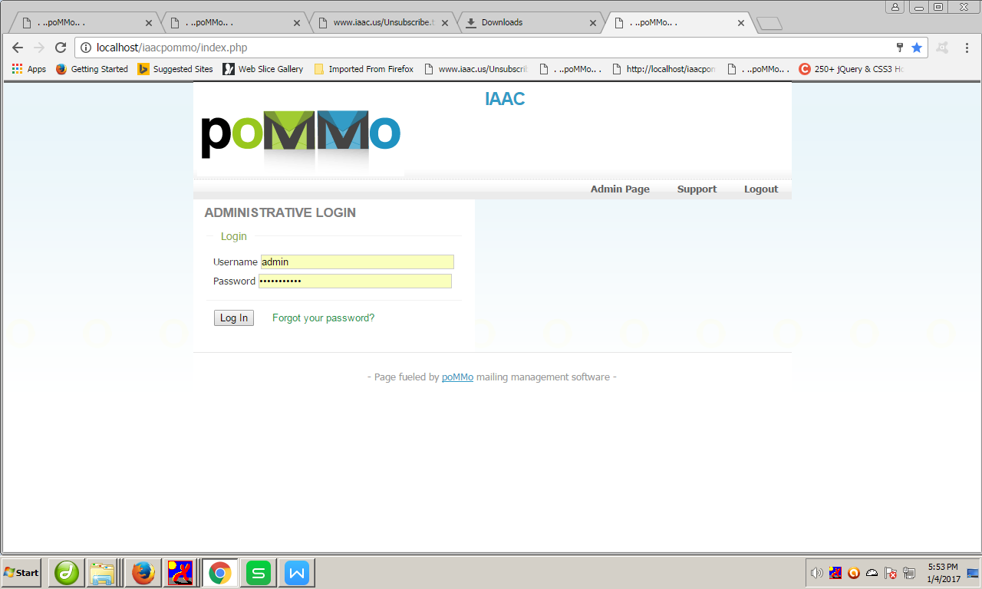

3.Select Subscribers => manage
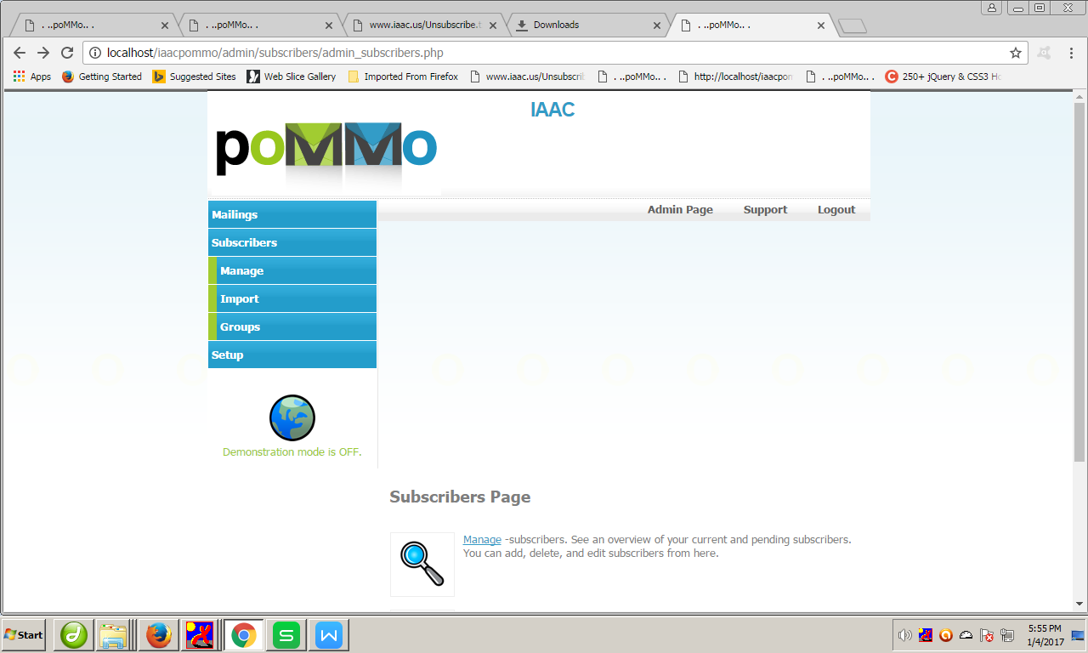

=>Select Remove subscribers
=>Enter emails that you want to unsubscribe (Take it from ww.iaacus/unsubscriber.txt )

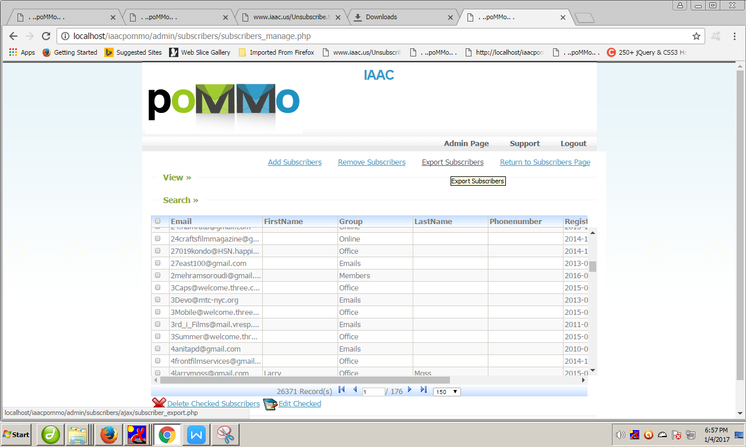

=>Enter Unsubscribe emails here.
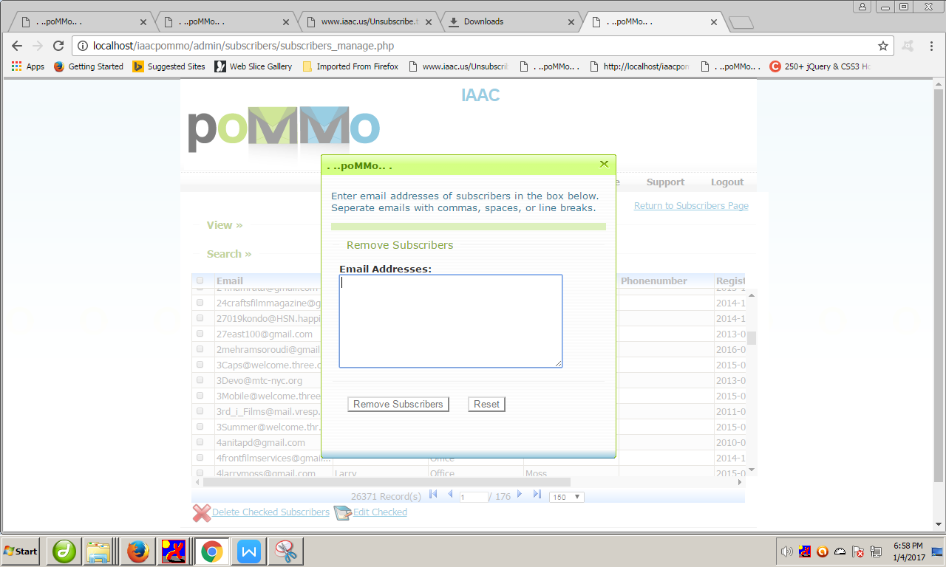

- Check it subscriber by selecting emails from grid window:

